# CHAPTER 5: DATA BASED MODELING OF ASM

This chapter describes the Scenario Based Model for the Assignment Management System.

## 5.1 INTRODUCTION

Sometimes software requirements include the necessity to create, extend or interact with a database or complex data structures need to be constructed and manipulated. The software team chooses to create data models as a part of overall requirements modelling. The entity-relationship diagram (ERD) defines all data objects that are processed within the system, the relationships between the data objects and the information about how the data objects are entered, stored, transformed and produced within the system.

## 5.2 DATA OBJECTS

A data object is a representation of composite information that must be understood by the software. Here, composite information means an information that has a number of different properties or attributes. A data object can be an external entity, a thing, an occurrence, a role, an organizational unit, a place or a structure.

## 5.2.1 NOUN IDENTIFICATION

We identified all the nouns whether they are in problem space or in solution space from our usage scenario.

Table 1: Noun Identification for Data Modelling

|  |  |  |  |
| --- | --- | --- | --- |
| Serial | Noun | S/P | Attributes |
| 1 | story | p |  |
| 2 | Requirement | P |  |
| 3 | Collection | P |  |
| 4 | Instructor | S | 11,12,13,14,15 |
| 5 | Student | S | 11,12,13,14,15 |
| 6 | Project | P |  |
| 7 | Application | P |  |
| 8 | System | P |  |
| 9 | User | S | 11,12,13,14,15 |
| 10 | Option | P |  |
| 11 | First name | S |  |
| 12 | Last name | S |  |
| 13 | Email | S |  |
| 14 | Phone number | S |  |
| 15 | Password | S |  |
| 16 | Account | P |  |
| 17 | Data | P |  |
| 18 | Validity | P |  |
| 19 | Character | P |  |
| 20 | Number | P |  |
| 21 | Regex | P |  |
| 22 | Sign up | S |  |
| 23 | Sign in | S |  |
| 24 | Database | S |  |
| 25 | Account recovery | S |  |
| 26 | Link | P |  |
| 27 | Webpage | P |  |
| 28 | Sign out | S |  |
| 29 | Process | P |  |
| 30 | Group | S | 31,32,33,34 |
| 31 | Group name | S |  |
| 32 | Section | S |  |
| 33 | Subject | S |  |
| 34 | Code | S |  |
| 35 | Assignment | S | 36,39,40,41,42 |
| 36 | Format | S |  |
| 37 | Time | P |  |
| 38 | Assignment submission | S | 37,42,67 |
| 39 | Assignment title | S |  |
| 40 | Assignment description | S |  |
| 41 | Deadline | S |  |
| 42 | Files | S |  |
| 43 | Message | S | 17, 37,67 |
| 44 | Comment | S | 17,37,67 |
| 45 | Posts | S | 37,47,67 |
| 46 | Announcement | P |  |
| 47 | Topic | P |  |
| 49 | Resubmission | S | 37,42,67 |
| 50 | Folder | P |  |
| 51 | GroupWise | P |  |
| 52 | Course wise | P |  |
| 53 | Error message | P |  |
| 54 | Late submission | S | 37,42,67 |
| 55 | Plagiarism | S |  |
| 56 | MOSS | P |  |
| 57 | Software | P |  |
| 58 | Result | P |  |
| 59 | Similarity | P |  |
| 60 | Evaluation | P |  |
| 61 | Marks | S |  |
| 62 | Mark distribution | S |  |
| 63 | Authentication | S |  |
| 64 | Assignment management | S |  |
| 65 | Group management | S |  |
| 66 | Communication | S |  |
| 67 | Date | S |  |

### 5.2.2 POTENTIAL DATA OBJECTS

* **User:**11-15
* **Student:**11-15
* **Instructor:**11-15
* **Group:**31-34
* **Assignment:** 36,39-42
* **Assignment submission:**37,42,67
* **Message:**37,67,68
* **Comment:**37,67,69
* **Posts:**37,47,67
* **Resubmission:**37,42,67
* **Late submission:**37,42,67

### 5.2.3 ANALYSIS FOR FINAL DATA OBJECT

* Instructor and student are all users of AMS and thus common attributes stored as data object User.
* Group stores group information such as group name, subject, and section code.
* Assignment stores assignment information such as assignment description, format, deadline and files.
* Assignment submission, late submission and resubmission are all submission of AMS and thus common attributes stored as data object Submission and these are under submit action.
* Message stores information sender, receiver, date, time and message description.
* Comment stores information such as comment description, date and time.
* Posts are the assignment posted in group by the instructor.

### 5.2.4 FINAL DATA OBJECT

|  |  |
| --- | --- |
| 1 | User: user_Id, first name, last name, email, password, phone number |
| 2 | Instructor: user_Id, first name, last name, email, password, phone number |
| 3 | Student: user_Id, first name, last name, email, password, phone number |
| 4 | Group: group_Id, group name, section, subject, code |
| 5 | Assignment: assignment_Id, format, title, description, file |
| 6 | Message: time, date, data, |
| 7 | Comment: time, date, data, |

## 5.3 DATA OBJECT RELATIONS

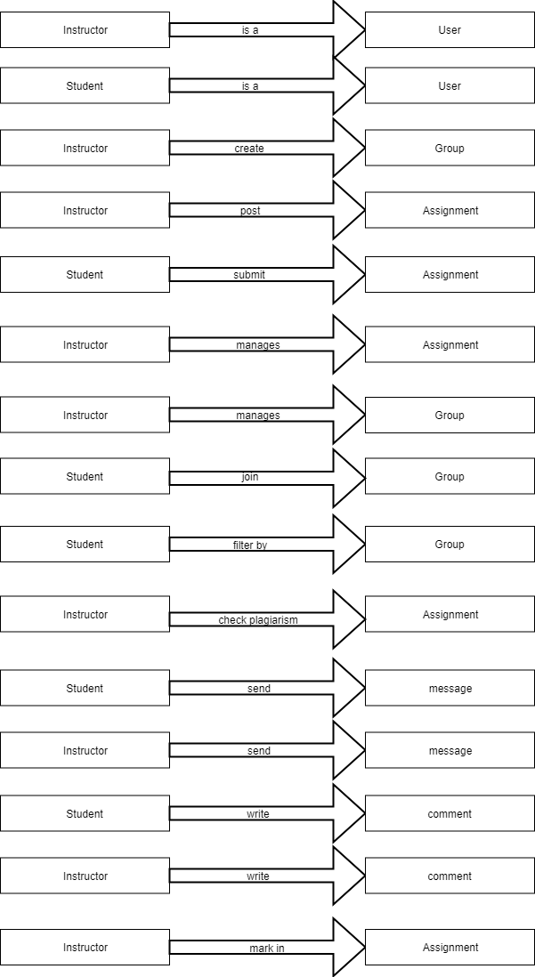

## 5.4 ENTITY RELATIONSHIP DIAGRAM

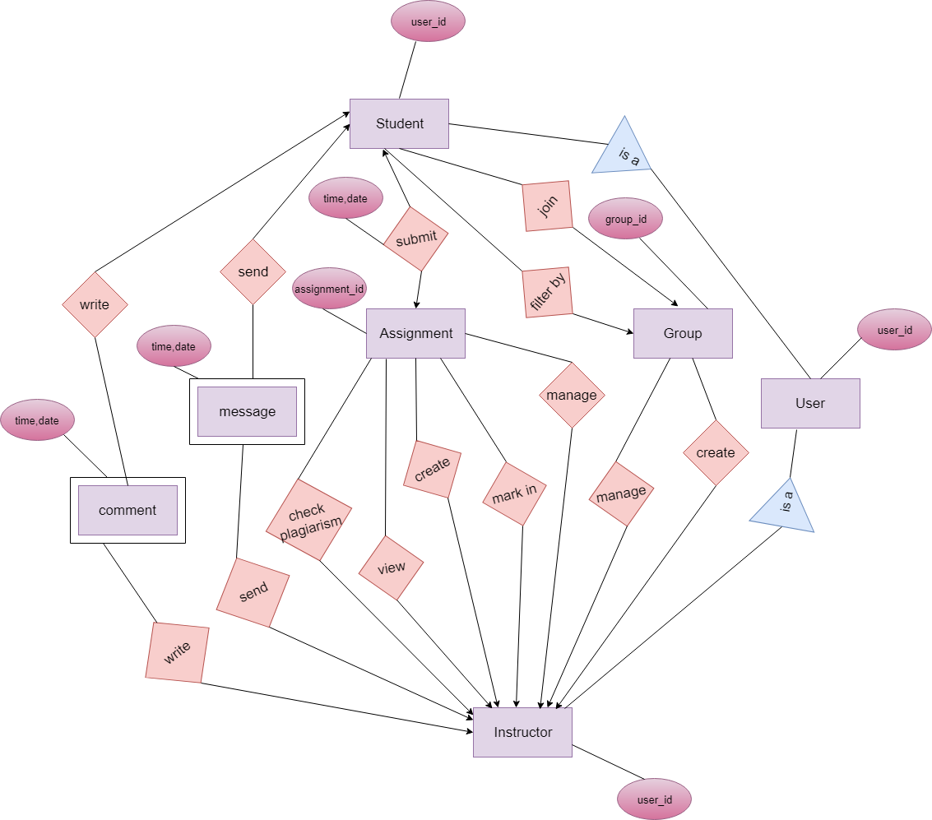

Figure –: Entity Relationship of Assignment Management System

|  |  |  |
| --- | --- | --- |
| User | | |
| Attributes | **Type** | **Size** |
| user_Id | VARCHAR | 40 |
| first_name | VARCHAR | 80 |
| last_name | VARCHAR | 40 |
| email | VARCHAR | 50 |
| password | VARCHAR | 30 |
| phone_number | VARCHAR | 15 |

|  |  |  |
| --- | --- | --- |
| Instructor | | |
| Attributes | **Type** | **Size** |
| user_Id | VARCHAR | 40 |
| first name | VARCHAR | 80 |
| last name | VARCHAR | 40 |
| email | VARCHAR | 50 |
| password | VARCHAR | 30 |
| phone number | VARCHAR | 15 |

|  |  |  |
| --- | --- | --- |
| Student | | |
| Attributes | **Type** | **Size** |
| user_Id | VARCHAR | 40 |
| first_name | VARCHAR | 80 |
| last_name | VARCHAR | 40 |
| email | VARCHAR | 50 |
| password | VARCHAR | 30 |
| phone number | VARCHAR | 15 |
| group_Id | VARCHAR | 40 |

|  |  |  |
| --- | --- | --- |
| Group | | |
| Attributes | **Type** | **Size** |
| group_Id | VARCHAR | 40 |
| group name | VARCHAR | 80 |
| section | VARCHAR | 40 |
| subject | VARCHAR | 50 |
| code | VARCHAR | 30 |

|  |  |  |
| --- | --- | --- |
| Assignment | | |
| Attributes | **Type** | **Size** |
| assignment_Id | VARCHAR | 40 |
| format | VARCHAR | 80 |
| title | VARCHAR | 40 |
| phone_number | VARCHAR | 50 |
| description | VARCHAR | 500 |
| file | BLOB | 1 |
| creation date | DATE | 30 |

|  |  |  |
| --- | --- | --- |
| Message | | |
| Attributes | **Type** | **Size** |
| user_id | VARCHAR | 40 |
| time | VARCHAR | 40 |
| date | DATE | 80 |
| data | VARCHAR | 40 |

|  |  |  |
| --- | --- | --- |
| Comment | | |
| Attributes | **Type** | **Size** |
| user_id | VARCHAR | 40 |
| time | VARCHAR | 40 |
| date | DATE | 80 |
| data | VARCHAR | 40 |

|  |  |  |
| --- | --- | --- |
| Assignment Submission | | |
| Attributes | **Type** | **Size** |
| user_Id | VARCHAR | 40 |
| assignment_Id | VARCHAR | 40 |
| time | VARCHAR | 80 |
| date | DATE | 40 |
| Files | BLOB | 1 |

|  |  |  |
| --- | --- | --- |
| Marks | | |
| Attributes | **Type** | **Size** |
| user_Id | VARCHAR | 40 |
| assignment_Id | VARCHAR | 40 |
| marks | NUMBER | 80 |